Remote Control User Manual v1.0
1.Check the power supply of the tag hardware and observe the flashing status of the LED indicator on the tag.
- Slow flashing: Unpaired (1-second flashing)
- Flash: Paired (0.2-second flash) Paired out of the box
Note: Both the tag hardware and the base station hardware need to be powered.
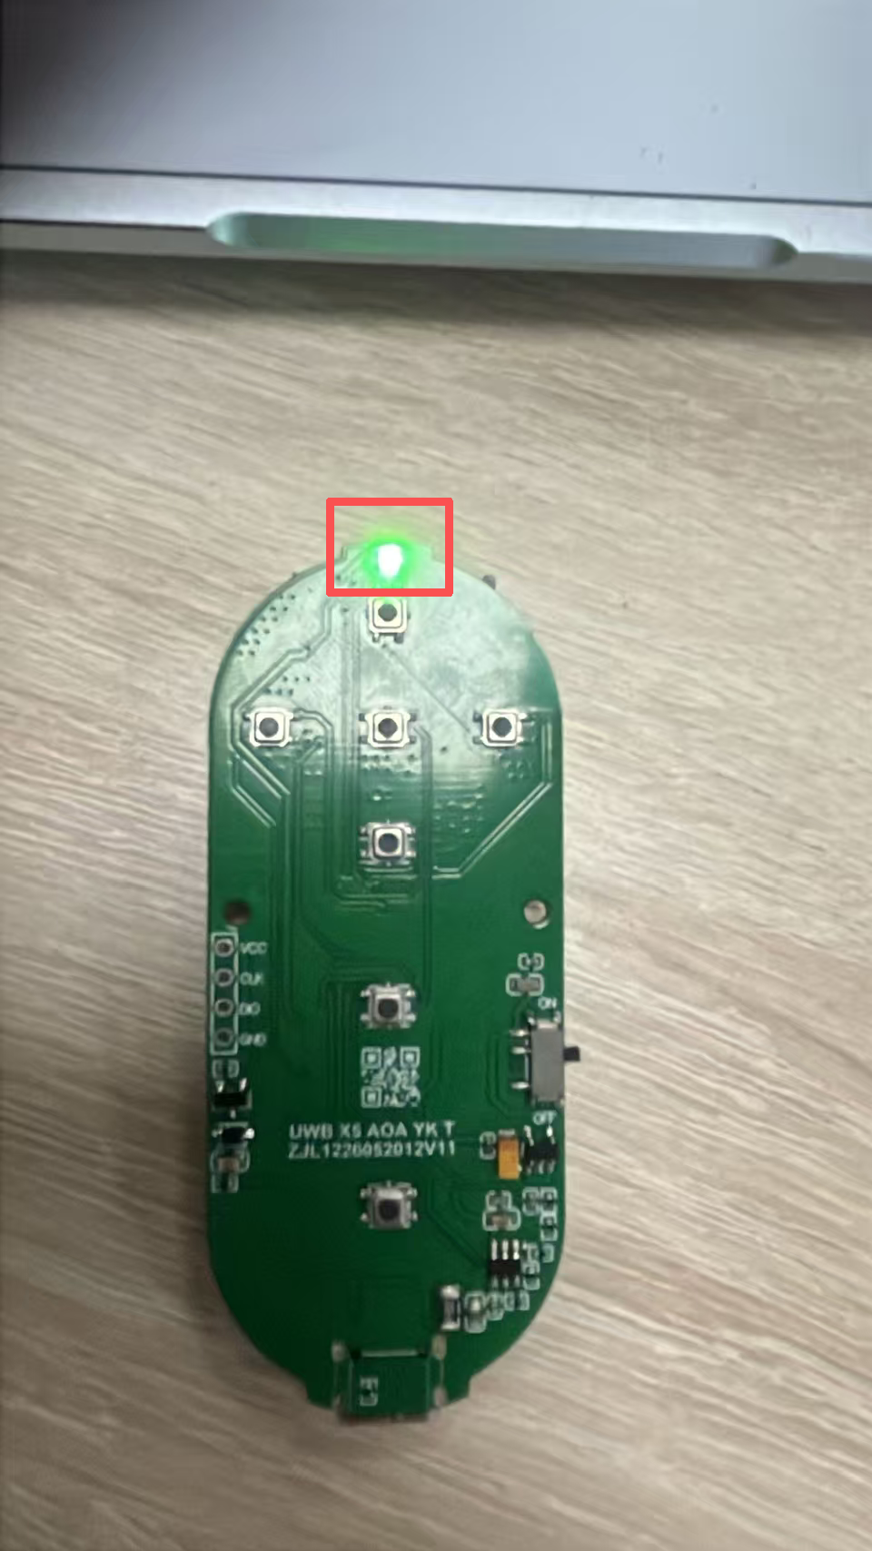

2.Remote control button instructions.
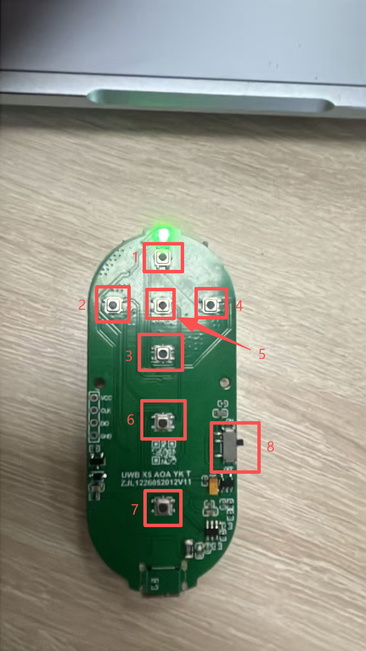
- 1-4 are the direction keys (respectively for forward, left, backward, and right)
- 5 has no effect. Users can customize it.
- 6 is the remote control button (double-click), switching to remote control mode.
- 7 is the follow button (double-click), which switches to the follow mode.
- 8 is the power-on/off button for the label hardware.

